SHALOM PRIMARY SCHOOL
P. 5 MATHEMATICS WEEKEND MIXED WORK WEEK 1, TERM 2, 2020

1. Multiply 247 by 3
2. Given digits 2, 4, 6 and 3.
a) Form any two 4 digit numbers formed using the above digits.
b) Write down the smallest and largest number formed using the above digits.
3. If b = 4, what is the value of b²?
4. Okello scored the following marks in mid term exams; 70, 80, 90, 75.
Find his range.
5a) Write the place value of each digit in 220_{four}.
b) Change 124_{five} to base ten.
c) Add; 2 1 3 _{five}
+ 2 1 _{five}
____________

P. 5 ENGLISH WEEKEND MIXED WORK WEEK 1, TERM 2, 2020

A. Read the poem very carefully and answer the questions that follow in full sentences.
MY SMALL MOTORCAR
I have a small motorcar
Through hard work did I buy her
Up to my home did I drive her
Vroom, vroom did the engine go.

Om my small motorcar
Her body is silver
Her seats are leather
Her steering is powered
And I proudly flash the lights

Of my small motorcar
I bought her a toolbox
With a spanner, a hammer and pliers
A jack and a screwdriver, all inside
I checked out her brakes
And all was well
With my small car
Alice Bafuluka
Questions;
1. What is the poem talking about?
2. How many stanzas does the poem have?
3. How did the speaker acquire the motorcar?
4. What sound does the car make?
5. What are the seatbelts made of?
6. Mention the equipment in the toolbox.
7. What is the body of the motorcar made of?
8. Who wrote the poem?
9. How does the writer flash the lights?
10. Give the title of the poem.

SHALOM PRIAMRY SCHOOL
P. 5 ENGLISH WEEKEND MIXED WORK WEEK 2, TERM 2, 2020

Rewrite the passage putting in all the capital letters and punctuation marks that are needed.
have some wine mr. johnstone said in an encouraging tone alice looked round the table but there was nothing on it but tea. i don’t see any wine, she remarked there isn’t any, said mr. johnstone. then it wasn’t right to offer it, said alice angrily. It wasnt right for you to sit at table without being invited, said mr. johnstone. I didnt know it was your table, said alice. its laid for a great many more than three

MATHEMATICS;
1. Prime factorise 18 and give your answer in subscript form.
2. Given the number 58,206.
a) Write the place value of 5 in the above number.
b) What is the sum of the value of 8 and 2 in the above number?
c) Expand the given number in exponent form.
3. What is the product of the third and fifth even numbers?
4. Study the venn diagram below and use it to answer the questions that follow.
F_{X} F_{Y}
2₁
3₂ 3₁ 2₂

a) Find the value of X.
b) What is the value of Y?
c) Find the GCF of F_{X} and F_{Y}.
d) Work out the LCM of F_{X} and F_{Y}.
5. Write 4 in words.
10

SHALOM PRIMARY SCHOOL
P. 5 MATHEMATICS WEEKEND MIXED WORK WEEK 3, TERM 2, 2020

1. In Work Hard and Grow Primary School, there are 536 children, 292 are boys.
a) How many girls are in that school?
b) How many more girls are there than boys?
c) Write the total number of children in words.
2. Study the shopping list below and use it to answer the questions that follow.
- Rice shs. 3000 each kg
- Wheat flour shs. 4,500 each kg
- Salt shs. 1,000 each kg
- Kimbo shs. 2,000 for a ½ kg
a) How much do you pay for 1kg of rice and 1kg of wheat flour?
b) What is the cost of 1kg of kimbo?
c) Begembe bought 2kg of rice and 1kg of salt. How much did he pay?
3. Calculate the perimeter of the figure below.
5cm
9cm
3cm
4cm
7cm

4. Study the figure below and use it to answer questions that follow.

4cm
5cm
3cm
4cm

a) Find the area of the big rectangle.
b) Find the area of the small rectangle.
c) What is the area of the shaded part?

P. 5 ENGLISH WEEKEND MIXED WORK WEEK 3, TERM 2, 2020

A. Read the passage below carefully and in full sentences answer the questions that follow.
Money is good and bad in many ways. We need money to buy food, pay taxes and pay school fees. We also need it to buy household property. Without money, we would not get good feeding or live happily.

Without money, parents would not build good houses or buy good dresses for us. Without money, people cannot buy good things from other countries or send their children to study in other countries.

However, money is also bad in various ways. People can use it to do bad things. For instance people are paid money to kill or tell lies about others. Other people steal because they want money. Without money, this evil would not happen.

If there wasn’t money in use, all things would be free. We could get the best food and services freely. We could also live in the best houses or join the best schools freely after our primary course this year.

Questions;
1. What is the passage about?
2. Mention one thing bought with money in the passage.
3. How would people live if they had enough money?
4. Why would parents need to send their children to good schools?
5. What would one need if one was to study in another country?
6. Which people buy things, according to this passage?
7. In which way is money taken to be bad?
8. What is the writer’s wish in the last paragraph?
9. In which class do you think is the writer to this passage?
10. Suggest a suitable title to this passage.

P. 5 ENGLISH WEEKEND MIXED WORK WEEK 4, TERM 2, 2020
Read the following conversation and answer the questions that follow in full sentences.
Mother : Kampala 041-456751, Mrs. Bamwoze speaking.
Daughter: Oh mum, this is Linda here. I’ve been trying to call you for
ages, but the line has been engaged. Then I got a wrong number before I got through.
Mother : I have been talking to granny, that is why you could not go
through.
Daughter: How is she?
Mother : She is fine and she sent you greetings.
Daughter: I rang to inform you that I shall be home late tonight. Lucy has
asked me to go with her to watch “Ndiwulira play” after our evening classes. Our patron for “save the youth again AIDS” said it is vital we see it.
Mother : Where will it be staged?
Daughter: Neeta Cinema from 6:30 – 8:30p.m.
Mother : How will you get back home?
Daughter: Lucy promised me a lift from her parents.
Mother : Well, if you must, you can. But your father and I do not like
these late nights. The streets are quite dangerous after dark.
Daughter: We will be careful, mum. Tell dad not to worry.
Mother : Make sure you confirm with Lucy’s parents whether they will
drop you. If they will not, take a special taxi immediately after the drama. Your father will pay the fare.
Daughter: Very well mum, give dad my love. I won’t be late.
Mother : Enjoy the film, both of you and try to learn from it.
Daughter: Thank you mum. Good bye for now.
1. How many people are involved in the conversation?
2. Why couldn’t Linda get the line very easily?
3. What information did Linda want to pass on to Mrs. Bamwoze?
4. Who is Linda’s Dad?
5. Who do you think is Lucy to Linda?
6. Who advised Linda to go to Neeta Cinema?
7. What alternative means of transport does Linda have to take back home?
8. Why don’t Linda’s parents like late night movement?
9. Give a word or group of words similar in meaning to the words below;
i) vital ii) granny
SHALOM PRIMARY SCHOOL
P. 5 MATHEMATICS WEEKEND MIXED WORK WEEK 4, TERM 2, 2020

1. Use the venn diagram given below to answer the questions.
X
Y
a b
c
f
d
e
g

a) List down the members of set x.
b) Find X∩Y
c) Find n(XUY)
d) Describe set X and Y.
2a) Find the perimeter of the figure below;

9cm
7cm
6cm

10cm

b) Find its area.
3. Change 9_{ten} to base five.
4. The figure below is a cuboid, use it to answer the following questions.

5cm

4cm
6cm

a) How many vertices does it have?
b) Find the area of the shaded part.
c) Work out its volume.

SHALOM PRIMARY SCHOOL
P. 5 ENGLISH WEEKEND MIXED WORK WEEK 5, TERM 2, 2020
Study the calendar carefully and answer the questions that follow.
Sun | Mon | Tue | Wed | Thur | Fri | Sat
 |  | 1 | 2 | 3 | 4 | 5
6 | 7 | 8 | 9 | 10 | 11 | 12
13 | 14 | 15 | 16 | 17 | 18 | 19
20 | 21 | 22 | 23 | 24 | 25 | 26
27 | 28 | 29 | 30 | 31
Questions;
1. What is the first day of the week?
2. On which day did the month above begin?
3. How many Thursdays are in the month?
4. Why do you think 23rd July is shaded?
5. How many days are in the above month?
6. Which month is next to the one above?
7. How many complete weeks are in the month above?
8. Which day was 24th according to the above calendar?
9. Write in full;
i) Wed ii) Sat.

MATHEMATICS;

1. Write 25,305 in words.
2. Write the value of 10².
3. Given the figure below.
3cm
3cm
4cm
2cm
y
x

a) Find the value of x.
b) What is the value of y?
4. Work out the following;
a) 2 2 3 4 3 0
+ 1 1 4 8 6 4
____________
b) 9 3 2 4 5 0
- 1 6 8 6 3
____________
5a) Find the area of the figure below.

8cm

b) Find its perimeter.
6. Use the symbols > , < to complete the statements below;
a) 10 x 10 ____ 10 + 10
b) 7 days _____ 1 fortnights

SHALOM PRIMARY SCHOOL
P. 5 ENGLISH WEEKEND MIXED WORK WEEK 6, TERM 2, 2020
The picture A – F tell a story. Study them carefully and then write one sentence to describe what is happening in each picture.
Use the words given below to help you.
writing, buying, sealing, riding, letter box, posting, stamps, bicycle, envelope
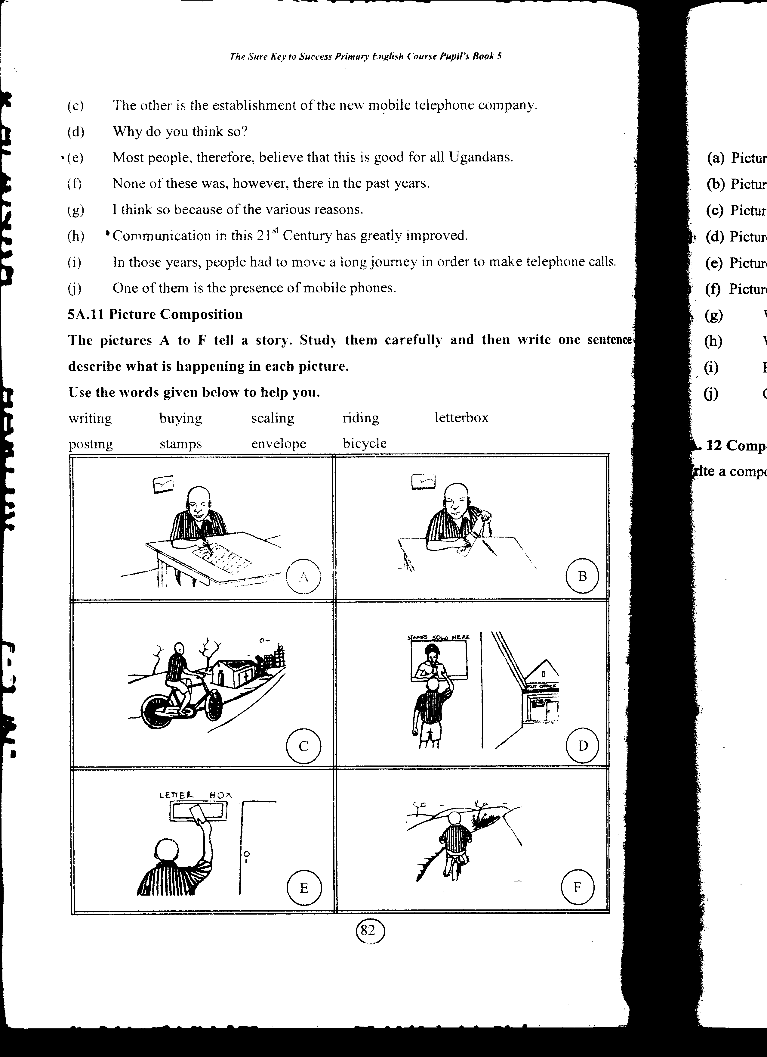

1. Picture A: _______________________________________________
2. Picture B: _______________________________________________
3. Picture C: _______________________________________________
4. Picture D: _______________________________________________
5. Picture E: _______________________________________________
6. Picture F: _______________________________________________
7. Where did the boy go after posting the letter?
8. What is the boy doing in picture D?
9. How did the boy travel to the post office?
10. Give a suitable title to this story.

P. 5 MATHEMATICS WEEKEND MIXED WORK WEEK 6, TERM 2, 2020

1. Multiply 146 by 27.
2. Find the unknown angles in the figures below.

a)
x
47⁰

t
p
150⁰
b)

70⁰

c)
50⁰

3. Given that x = 2, y = 4 and z = 3, find the value of;
a) x + y + z
b) 2x – y
c) 4 + z².
4a) Change 4 hours to minutes.
b) How many hours are there in 120 minutes?
5. Write 24.45 in words.

SHALOM PRIMARY SCHOOL
P. 5 ENGLISH WEEKEND MIXED WORK WEEK 7, TERM 2, 2020
Read the advertisement and then answer the questions in full sentences.
DOWN TOWN INTERNET CAFÉ
P.O BOX 22 KATWE – KAMPALA
NOTICE : Job opportunities
Applications are invited from Ugandans to fill the following posts (vacancies) in the internet café above urgently.
Post: a) Technician (1post)
b) Computer wizard (2 posts)
c) Computer trainers (2 posts)
d) Security guard (1post)
Age: Between 18 and 25 years
Salary: Very attractive
Qualification: A degree in computer repair and maintenance.
Note: Security guard: Primary Leaving Examination Certificate.
All applicants must be fluent in English and Kiswahili.
Interested candidates should apply to;
Down Town Internet Café,
P.O Box 22 Katwe.
Not later than 31st August, 2015.
Management
20/05/2015
Questions;
1. What is the advertisement about?
2. When was the advertisement written?
3. Who made the advertisement?
4. What was the last date for receiving applications?
5. According to the notice, who received the applications?
6. Where is the internet café located?
7. What was needed for the post of a security guard?
8. Which two languages were considered for the job?
9. To whom were the applications sent?

P. 5 MATHEMATICS WEEKEND MIXED WORK WEEK 7, TERM 2, 2020

1. Solve; 4m – 2 = 18
2. The graph below shows the number of tourists who visited Uganda Museum during the CHOGM weekend.

80

60

40

20

0
Thur Wed Sat Fri Sun
Days of the week
a) How many tourists visited the Museum on Friday?
b) On what day was the number of tourists highest?
c) Calculate the total number of tourists who visited the Museum.
d) If each tourists was charged shs.10,000 entrance fee, how much money did the management of Uganda Museum collect on Saturday?
2
1
3. Add; 1 + 7
8 8
4. Given that n(A) = 20, n(B) = 25 and n(A∩B) = 5.
a) Complete the venn diagram below.
n(A) = ___ n(B) = 25

20 – 5
15 5 ___

b) Find n(B – A)
c) Find n(AUB)

SHALOM PRIMARY SCHOOL
P. 5 ENGLISH WEEKEND MIXED WORK WEEK 8, TERM 2, 2020

The graph below shows the crimes and number of cases that were recorded at Kasangati Police Station in April 2011. Study the given information carefully and then answer the questions in full sentences.

55
50
45
40
35
30
25
20
15
10
5
0
Rape
Domestic violence
Murder
Defilement
Riots
Mob justice
Child abuse
Theft

Crimes committed
Questions;
1. What is the graph about?
2. When were the crimes recorded?
3. From which Police Station was the information obtained?
4. Which crime recorded the highest number of cases?
5. Why do you think theft cases are very high?
6. How many defilement cases were reported to the police station?
7. Which crime registered the lowest number of cases?
8. What do you think is the main duty of the police?
9. How many more cases were recorded on defilement than rape?
10. Suggest anyone possible way of reducing crimes in your community?

P. 5 MATHEMATICS WEEKEND MIXED WORK WEEK 8, TERM 2, 2020

1. In a class of 30 pupils, 1 of them are boys and the rest are girls.
3
a) What is the fraction of girls in that class?
b) Find the number of boys in the class.
2. Reduce 4 to its lowest terms.
12
3a) Tell the morning time shown on the clock face below.
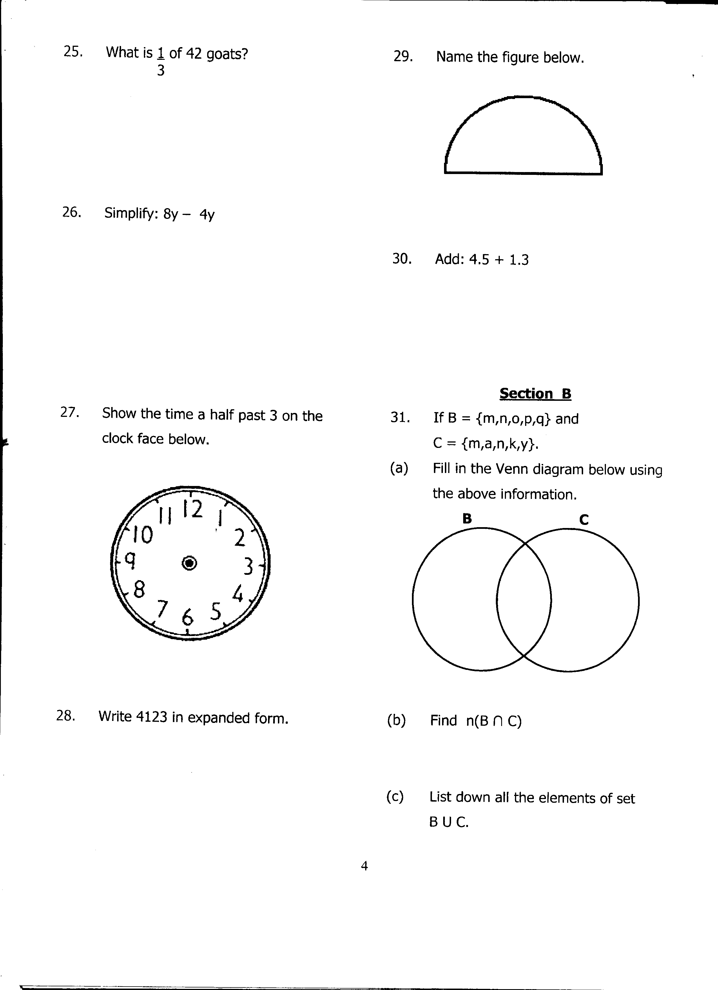

b) How many minutes are there in 2½ hours?
4. Study the circle below and answer the questions that follow.
B
Y
X
A
O
.

a) Name point O
b) Name the lines;
i) AB
ii) OB
iii) XY
c) If AO is 3cm, find AB in cm.
5. What is the LCM of 30 and 40?

SHALOM PRIMARY SCHOOL
P. 5 MATHEMATICS WEEKEND MIXED WORK WEEK 9, TERM 2, 2020

1. Below is a rectangle, use it to answer the questions.
7cm
4cm

T

R

a) How many lines of folding symmetry has the above figure?
b) Find the length of;
i) T =
ii) R =
c) Work out the total distance around the figure.
d) Find its area.

2. Subtract; weeks Days
5 3
- 3 5
___________
3. Given that a = 2, b = 3 and c = 4, find the value of 2a + 3b.
4. Study the venn diagram below carefully and answer questions about it.
T V
2 1 7
3
4 5 8
9

a) List the elements of set V.
b) Find;
i) n(T –V)
ii) n(T∩V)^{I}.

P. 5 ENGLISH WEEKEND MIXED WORK WEEK 9, TERM 2, 2020

The notice below was written at the Main Gate to Mbale Regional Hospital. Read it carefully and answer the questions in full sentences.

MBALE REGIONAL HOSPITAL
P.O Box 9, Mbale
PUBLIC NOTICE
VISITING HOURS
7:00a.m – 8:00a.m - morning
12:30p.m – 2:00p.m - afternoon
6:00p.m – 8:00p.m - evening
Alcohol and smoking not allowed.
Management

Questions;
1. What is the notice about?
2. Where was the notice written?
3. Who wrote the notice?
4. How many times is a person allowed to visit a patient?
5. Why is it necessary to visit a patient?
6. According to the notice, what is not allowed in the hospital?
7. At what time do the visiting hours end in the evening?
8. Write in full;
i) a.m
ii) p.m
9. To whom is the notice addressed?

SHALOM PRIMARY SCHOOL
P. 5 ENGLISH WEEKEND MIXED WORK WEEK 10, TERM 2, 2020

Read the following instructions carefully and answer the questions in full sentences.
THE LOST BAG
The general public is informed that I lost my red bag
from Kalerwe market. It contained my Bank card, a Nokia phone and 15,000/=. It got lost on Monday, 27th April, 2015.
Big rewards await whoever will get it and returns it to me.
Jackie Tel; 0752506070

Questions;
1. What kind of information is given above?
2. Who wrote it?
3. How can you contact the owner?
4. Who are informed?
5. When did the bag get lost?
6. What important items were in the bag?
7. What will happen to the person who gets it and returns it to the owner?
8. Where did the bag get lost from?
9. Give the title for the information.
10. Write in full; Tel.

P. 5 MATHEMATICS WEEKEND MIXED WORK WEEK 10, TERM 2, 2020

1. Find the square root of 36.
2. Using a ruler, a pencil and a pair of compasses, construct an angle of 90⁰.
3. Study the figure below and answer the questions that follow.

p

12cm
6cm
8cm

a) Find the value of p.
b) Find the perimeter of the triangle above.
c) Work out the area of the figure.

4. Epupi went for shopping with shs.25,000 and bought the following items;
- 3kgs of meat at shs.5000 a kg.
- A half litre of milk at shs.2000 per litre.
- 2 pens at shs.2,000
- 4 bars of soap at shs.1,500 a bar.
a) Calculate his total expenditure.
b) What was the change after buying all the items?

5. Complete the magic square below and show your working.
8 | 1 | 6
3 | _ | _
4 | _ | 2

